Sashiko through the seasons
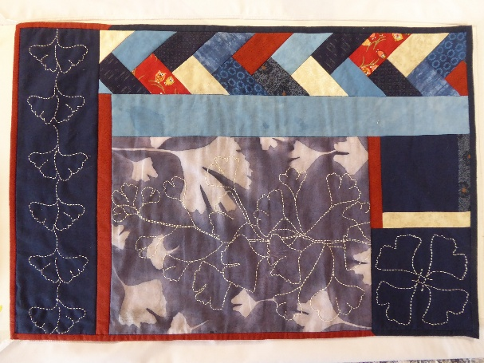
This is my finished piece of Gingko Blues. It is a suggested layout of the elements created in the class. You can rearrange your pieces in a manner pleasing to you. You might want two rows of the braid or more sashiko pieces. You can choose a square layout rather than the rectangle.

Below are some of the elements from my Cherry Blossom piece. Again, the arrangement of the pieces is up to you.

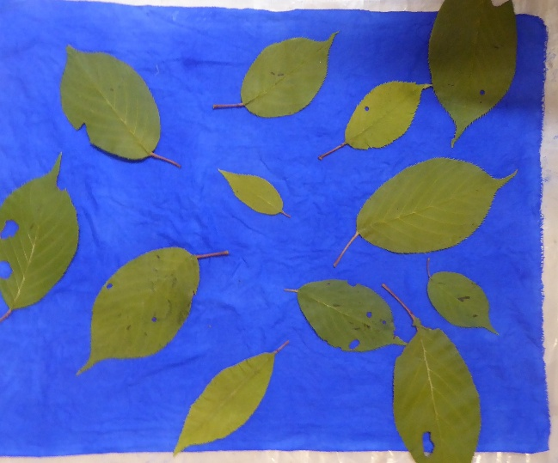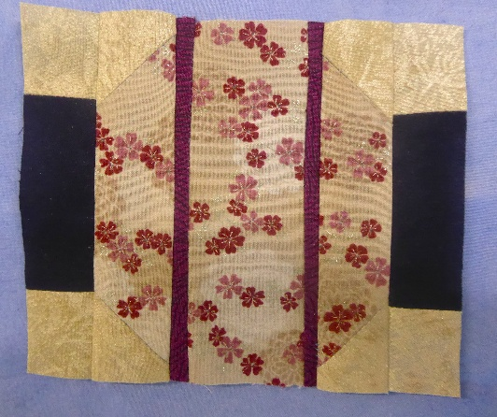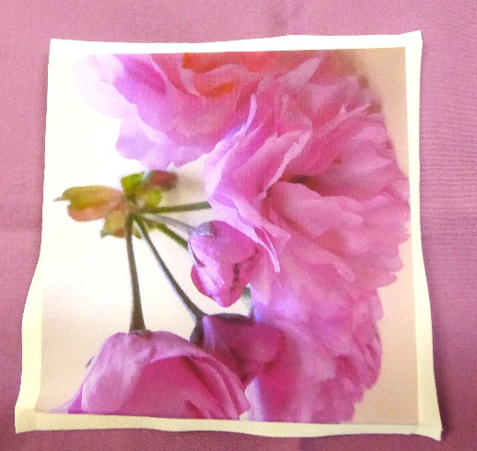
Leaf resist dyeing oriental lantern photo transfer to fabric

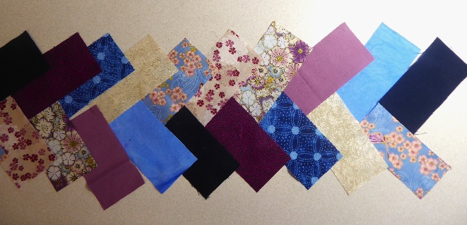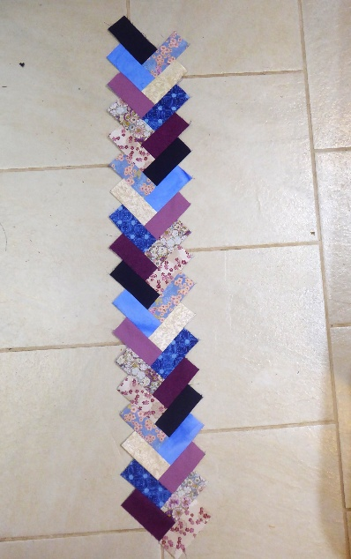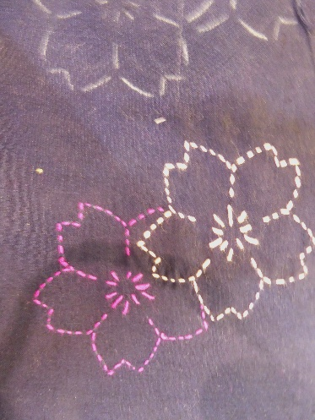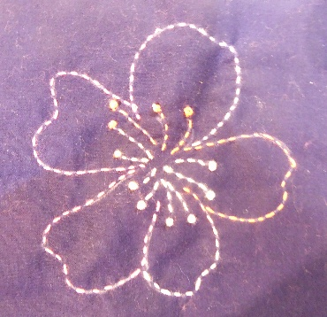
Japanese braid layout and sewn together sashiko stitched pieces

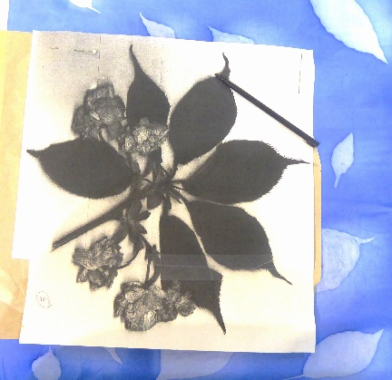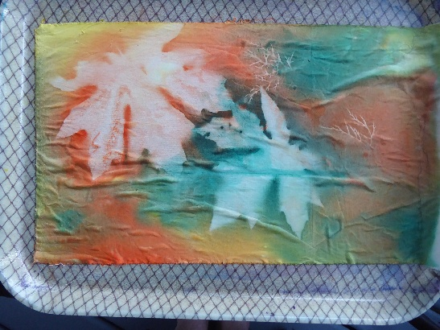
Making a sashiko design from actual leaves maple leaf resist dye results

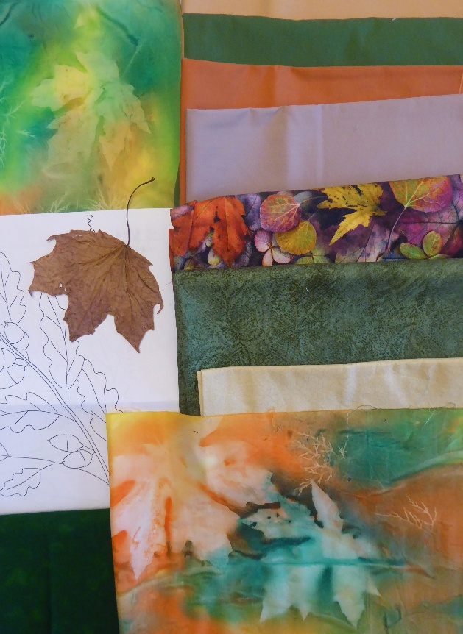
Choosing coordinating fabrics for an autumnal design- maple or oak leaves

